IMPLEMENTATION GUIDE OF
ANDROID SOFTWARE DEVELOPMENT KIT

Version 1.0


93 B New Eskaton Road
Dhaka 1000, Bangladesh
Work: +880 9666 77 6969. +880 2 4831 6969
Fax: +880 2 913 2172
E-mail: info@sslwireless.com
www.sslwireless.com

DOCUMENT REVISION HISTORY
Version: | V1.0
Release Date: | June 17, 2019
Document Owner: | Software Shop Limited
Document Classification: | Confidential

This page intentionally left blank

Table of Contents
Steps to Implement SSL COMMERZ SDK on Users Project 5
Step 1 5
Step 2 5
Step 3 6
Optional Initializer 7
Customer Initializer 7
EMI Initializer 7
Product Initializer 7
Shipment Initializer 7
Additional Initializer 7
Method to Submit Optional Data 7
Return Type 8

Steps to Implement SSL COMMERZ SDK on Users Project

Step 1
Users need to add below dependency to their build.gradle (app module) :
implementation 'com.android.support:support-compat:28.0.0'
implementation 'com.android.support:appcompat-v7:28.0.0'
implementation 'com.android.support:support-v4:28.0.0'
implementation 'com.android.support:design:28.0.0'
implementation 'com. google. code. gson: gson:2.8.5'
Note: If users project supports androidx artifacts, then they need to change dependency according to androidx.

Step 2
To insert the Dependency Mentioned in step 1, users need to follow the below steps:
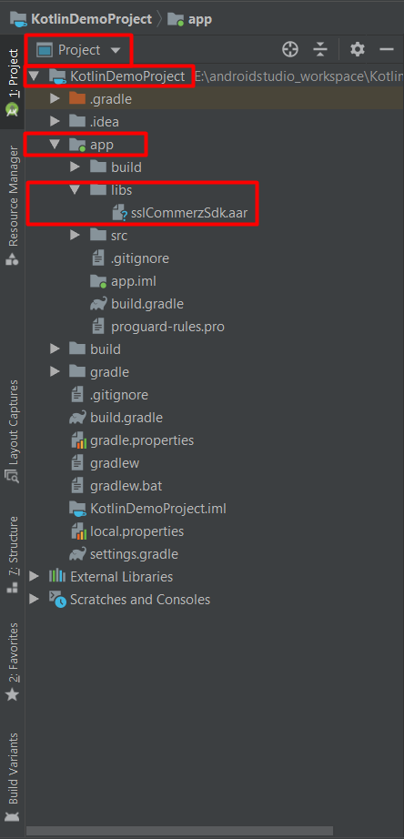
From top left corner of project pane,
“Select” Project 🡪 app 🡪 libs 🡪 “Paste” sslCommerzSdk.aar in libs folder

Afterwards, users need to additional codes to the project after inserting sslCommerzSdk.aar in libs folder by following steps below:

“Select” Project app 🡪 build.gradle (app module) and add below code and sync project:

repositories {
flatDir {
dirs 'libs'
}
}
implementation (name: 'sslCommerzSdk', ext:'aar')

Afterwards, users need to sync the project and the below code will appear on the project pan:
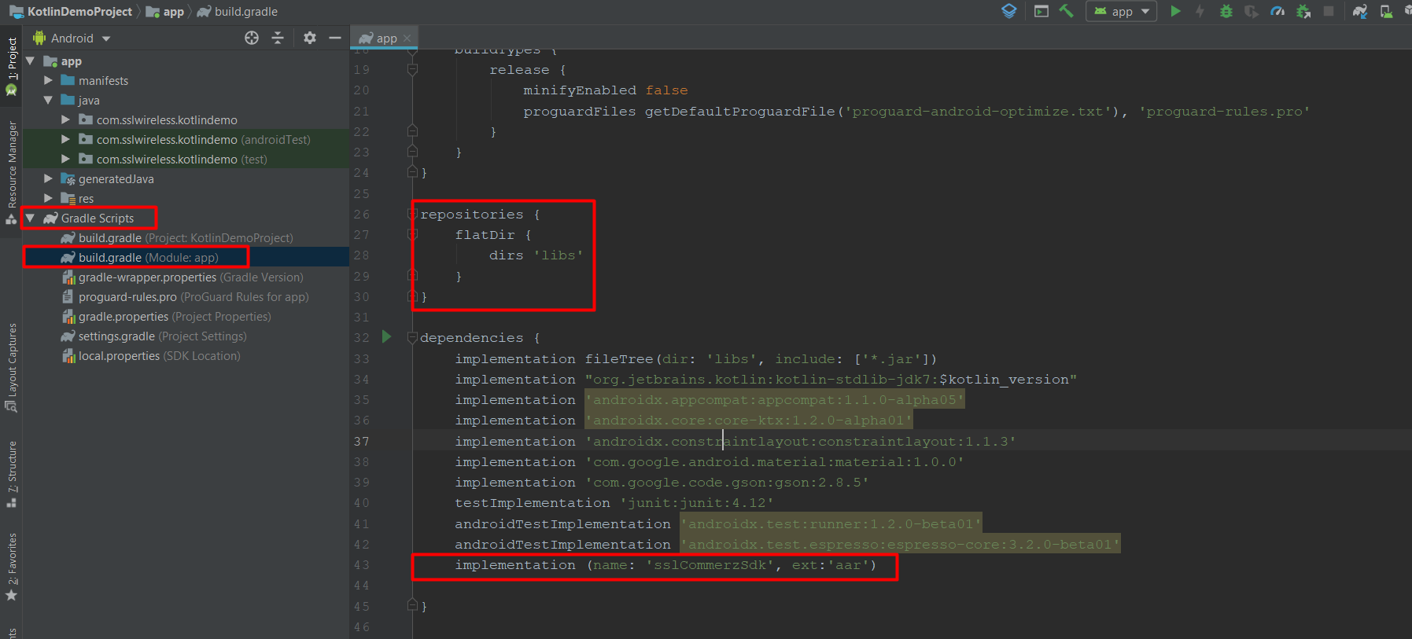

Step 3
After successfully completing SDK integration, users can request for transaction. In order to commence transaction, users need to pass SSLCommerzInitialization.

SSLCommerzInitialization (Mandatory to initiate SSL Commerz):
final SSLCommerzInitialization sslCommerzInitialization = new SSLCommerzInitialization ("yourStoreID","yourPassword", amount, SSLCCurrencyType.BDT,"123456789098765", "yourProductType", SSLCSdkType.TESTBOX);

Also, users can add optional field like below:
final SSLCommerzInitialization sslCommerzInitialization = new SSLCommerzInitialization ("yourStoreID","yourPassword", amount, SSLCCurrencyType.BDT,"123456789098765", "yourProductType", SSLCSdkType.TESTBOX).addMultiCardName(“”).addIpnUrl(“”);

Afterwards, user need to call below class to connect with SSLCommerz:
IntegrateSSLCommerz
.getInstance(context)
.addSSLCommerzInitialization(sslCommerzInitialization)
.buildApiCall(this);

Note: In addition to SSLCommerzInitialization, user can also pass optional initializers if required.

Optional Initializer

Customer Initializer
final SSLCCustomerInfoInitializer customerInfoInitializer = new SSLCCustomerInfoInitializer("customer name", "customer email",
"address", "dhaka", "1214", "Bangladesh", “phoneNumber”);

EMI Initializer
final SSLCEMITransactionInitializer emiTransactionInitializer = new SSLCEMITransactionInitializer(1);

Product Initializer
final SSLCProductInitializer productInitializer = new SSLCProductInitializer ("food", "food",
new SSLCProductInitializer.ProductProfile.TravelVertical("Travel", "10",
"A", "12", "Dhk-Syl", "N/A", "AAA",
"DDD"));

Shipment Initializer
final SSLCShipmentInfoInitializer shipmentInfoInitializer = new SSLCShipmentInfoInitializer ("Courier",
2, new SSLCShipmentInfoInitializer.ShipmentDetails("AA","Address 1",
"Dhaka","1000","BD"));

Additional Initializer
final SSLCAdditionalInitializer additionalInitializer = new SSLCAdditionalInitializer ();
additionalInitializer.setValueA("Value Option 1");
additionalInitializer.setValueB("Value Option 1");
additionalInitializer.setValueC("Value Option 1");
additionalInitializer.setValueD("Value Option 1");
Note: User add optional field as mentioned in STEP 3 and simply call specific class add Method.

Method to Submit Optional Data
IntegrateSSLCommerz
.getInstance(context)
.addSSLCommerzInitialization(sslCommerzInitialization)
.addEMITransactionInitializer(emiTransactionInitializer)
.addCustomerInfoInitializer(customerInfoInitializer)
.addProductInitializer(productInitializer)
.buildApiCall(this);

Return Type
SL | Type | Method | Description
 | String | getAPIConnect() | API Connection Status -  INVALID_REQUEST : Invalid data imputed to call the API  FAILED : API Authentication Failed  INACTIVE : API User/Store ID is Inactive  DONE : API Connection Success
 | String | getStatus() | Return VALID/VALIDATED or FAILED status for this transaction.
 | String | getSessionkey() | An unique session id for this transaction generated from SSLCOMMERZ gateway.
 | String | getTranDate() | Transaction Date and time.
 | String | getTranId() | Transaction ID that was generated and sent from Merchant-end.
 | String | getValId() | A Validation ID against the Transaction which is provided by SSLCOMMERZ.
 | String | getAmount() | The total Transaction Amount sent from Merchant-end including the Commissions added by SSLCOMMERZ and Bank.
 | String | getStoreAmount() | The total Transaction Amount sent from Merchant-end.
 | String | getBankTranId() | An unique transaction id generated by bank for this Transaction.
 | String | getCardType() | The Bank Gateway Name that customer selected.
 | String | getCardNo() | Customer’s Card number; only for BRAC and DBBL, not for Internet Banking.
 | String | getCardIssuer() | Credit/Debit Card Issuer Bank/Company Name
 | String | getCardBrand() | Credit/Debit Card Brand Name. Like VISA, Master etc
 | String | getCardIssuerCountry() | Card issuer country in full length.
 | String | getCardIssuerCountryCode() | Card issuer country code.
 | String | getCurrencyType() | Merchant Store Provided Currency. Like : USD , BDT
 | String | getCurrencyAmount() | Merchant Store Provided Amount.
 | String | getCurrencyRate() | Without Our Default Currency(BDT) if any merchant provide Other Currency then Conversion rate will be sent.(Google Currency Rate )
 | String | getBaseFair() | Merchant Store Provided Amount.
 | String | getValueA() | If any kind of optional value.
 | String | getValueB() | If any kind of optional value.
 | String | getValueC() | If any kind of optional value.
 | String | getValueD() | If any kind of optional value.
 | String | getAPIConnect() | Valid/Invalid (Based on Your Credentials)
 | String | getValidatedOn() | First Validation Date time
 | String | getGwVersion() | Version of payment gateway.
 | String | getRiskLevel() | Get risk-level for this transaction. The return value will be 0 or 1. If 0 then the transaction is safe . If 1 then the transaction is risky.
 | String | getRiskTitle() | Get the status of the transaction.

--- End of Document ---

